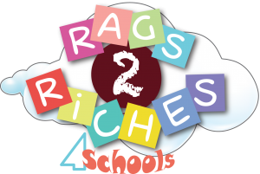
*** DATE FOR YOUR DIARY ***
On THURSDAY 25TH JANUARY at 9am

– Rags 2 Riches for schools will be making collection at school, so please support it again and now more than ever these clothes and items are desperately needed.
A great opportunity to sort out your wardrobe before the winter. There was a good programme on the BBC about what happens to the clothing if you are interested: http://www.bbc.co.uk/programmes/articles/3NCQT8fPDn9KfbLGmqqGZvF/the-secret-life-of-your-clothes which can be watched on YouTube. The clothing becomes affordable clothing around the world, we sell the clothes on – as an example some of the clothing will then be sold on market stalls in Africa.
The Rags 2 Riches bags will be sent home next week but please feel free to use normal bin bags as well!
We will let you know details of where to put the bags on the day in due course.
Thank you in advance for your continued support.

