BOWBROOK HOUSE SCHOOL FIXTURES
U16’s Boys Rugby

AGAINST: Bredon School

VENUE: Bowbrook

DATE: Wednesday 4th October 2023 KO: 2.15pm

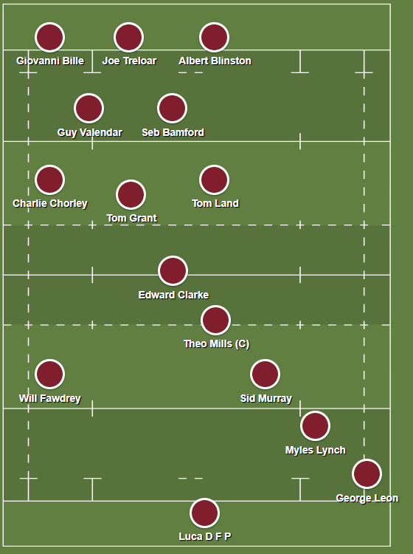
Subs

Kieran Wall

Antonius Makar

Dan Underwood

James Davies

LEAVE SCHOOL AT: N/A

PICK UP TIME IS: End of the day

MEET: Changing rooms @ 1:45

☺Please remember to excuse yourselves from lessons that you will be missing.

☺You will need to get permission from your parents for every match you are selected for. Please obtain a written note in your homework diaries and present it to Mr Swain or Mr Draper at least 24 hours prior to match day.

