BOWBROOK HOUSE SCHOOL FIXTURES
U11’s Tag Rugby

AGAINST: Primary Tag Festival

VENUE: Bowbrook

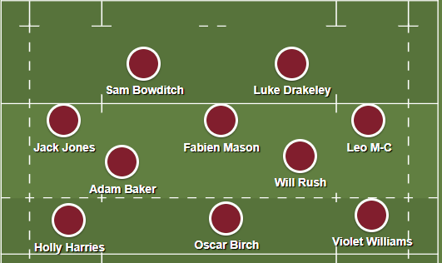
DATE: Monday 16th October

PICK UP TIME IS: End of the School Day

MEET: Changing rooms @ 1:45pm

☺Please remember to excuse yourselves from lessons that you will be missing.

☺You will need to get permission from your parents for every match you are selected for. Please obtain a written note in your homework diaries and present it to Mr Swain or Mr Draper at least 24 hours prior to match day.

