BOWBROOK HOUSE SCHOOL FIXTURES
U14’s Boys Rugby

AGAINST: Bredon School

VENUE: Bredon

DATE: Thursday 5th October 2023 KO: 2.15pm
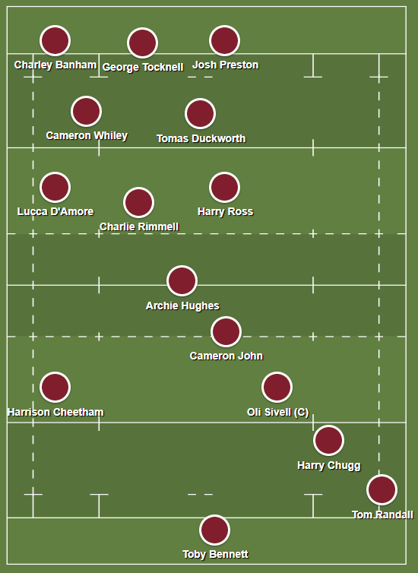
Subs

Rhys Hopkins

LEAVE SCHOOL AT: 1:15pm

PICK UP TIME IS: End of the day

MEET: Changing rooms @ 1:00

☺Please remember to excuse yourselves from lessons that you will be missing.

☺You will need to get permission from your parents for every match you are selected for. Please obtain a written note in your homework diaries and present it to Mr Swain or Mr Draper at least 24 hours prior to match day.

A Packed Lunch is required for this fixture.

