BOWBROOK HOUSE SCHOOL FIXTURES
U11’s Tag Rugby

AGAINST: Holy Redeemer

VENUE: Bowbrook

DATE: Monday 2nd October KO: 2.00pm

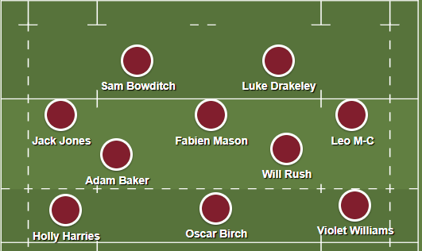

LEAVE SCHOOL AT: N/A

PICK UP TIME IS: End of the School Day

MEET: Outside the PE Office

☺Please remember to excuse yourselves from lessons that you will be missing.

☺You will need to get permission from your parents for every match you are selected for. Please obtain a written note in your homework diaries and present it to Mr Swain or Mr Draper at least 24 hours prior to match day.

