 | Monday | Tuesday | Wednesday | Thursday | Friday
Prep & Junior Lunch  12.00 –  1pm |  |  | Recorder Club  Miss Smith, (Music Rm)  12.30  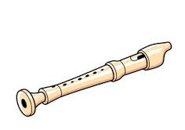  BUG Group Lessons  Mr Jones (Music Rm)  Timetabled |  | BUG Group Lessons  Mr Jones (Music Rm)  Timetabled
Middle& Senior  Lunch |  | String Group  tbc    (Mrs Corton)  Lunch 1pm  Main Hall  1pm |  | Jazz Group  Hall  (Mrs Hughes)  1pm   | Upper Chamber Choir 1.30  Music Rm  (Mrs Izod)  
Period 6 |  | Middle School Choir  Hall   |  | Infant Choir  Ms Smith    Junior Samba Drumming Club    Mr Booton  3.30 4pm (J3-J6) Music Rm | Junior Choir  Hall  
After School  4.05-5pm | Lower Chamber Choir (Hall)    (invite only) | Orchestra  Hall  (invite only)   |  | GCSE Composition Support Sessions  Mac Suite  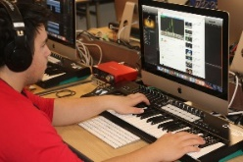

Music Extra - Curricular Timetable

